DIRECTORATE OF FAMILY WELFARE (GOVT. OF NCT OF DELHI)
‘B’ & ‘C’ WING, 7TH LEVEL, VIKAS BHAWAN-2
CIVIL LINES, NEW DELHI- 110054

National Deworming Day
10th February, 2020

As per a survey conducted by National Centre for Disease Control (NCDC) nearly 28% of children in Delhi were found to be infected with one or other type of intestinal worm. Intestinal worms significantly increase the risk of malnutrition including anemia among our population particularly in children & adolescents as these formative years are marked by accelerated growth & development.
The anemia prevalence in Delhi is in excess of 50% across most of the age groups which is a cause of serious concern and is threatening to turn what we consider our demographic dividend into a liability. It must be known to all that Anemia prevalence is high across the society irrespective of gender, age and socio-economic status.
With an aim to intensify efforts towards reducing the prevalence of Soil Transmitted Helminths (STH)/Intestinal worms, as a part of Anemia prevention and control strategy among the children and adolescents, National Deworming Day (NDD) campaign is conducted twice a year in Delhi since the year 2017.
NDD Campaign | Target | Beneficiaries (1-19 year) administered Albendazole during the campaign | Coverage (%)
February, 2017 | 38,87,437 | 31,21,586 | 80.30
August, 2017 | 37,28,688 | 29,24,094 | 76.20
February, 2018 | 36,89,648 | 29,77,998 | 80.71
August, 2018 | 38,86,911 | 30,54,892 | 78.60
February, 2019 | 43,50,000 | 31,50,611 | 72.42
August, 2019 | 45,40,261 | 35,15,107 | 77.42
As a part of the campaign, age appropriate dose of Tablet Albendzaole is administered to the children in 1-19 year age-group through Anganwadi Centres and Schools (both Govt./aided and Unaided) across the State in a pulse mode. Drugs are administered by teachers and anganwadi workers that are trained before every round.
Coverage during the last six campaigns conducted in 2017, 2018 & 2019 may be seen as under:

Coverage in Private/Unaided schools has improved significantly during the last three (03) rounds as per the details as under:
NDD Campaign | Target | No. of students administered Albendazole during the campaign | Coverage (%)
August, 2018 | 200000 | 1,02,927 | 51.46
February, 2019 | 550000 | 2,85,337 | 51.87
August, 2019 | 700000 | 4,84,772 | 69.25

However, there remains a scope of improvement considering the fact that more than 15.0 lac children are enrolled in Unaided schools in Delhi. School administration and Parents of children are requested to join this important public health initiative that is in greater interest of our children & adolescents.
NDD Campaign has also received support from professional bodies like Indian Academy of Pediatrics (IAP), Delhi.
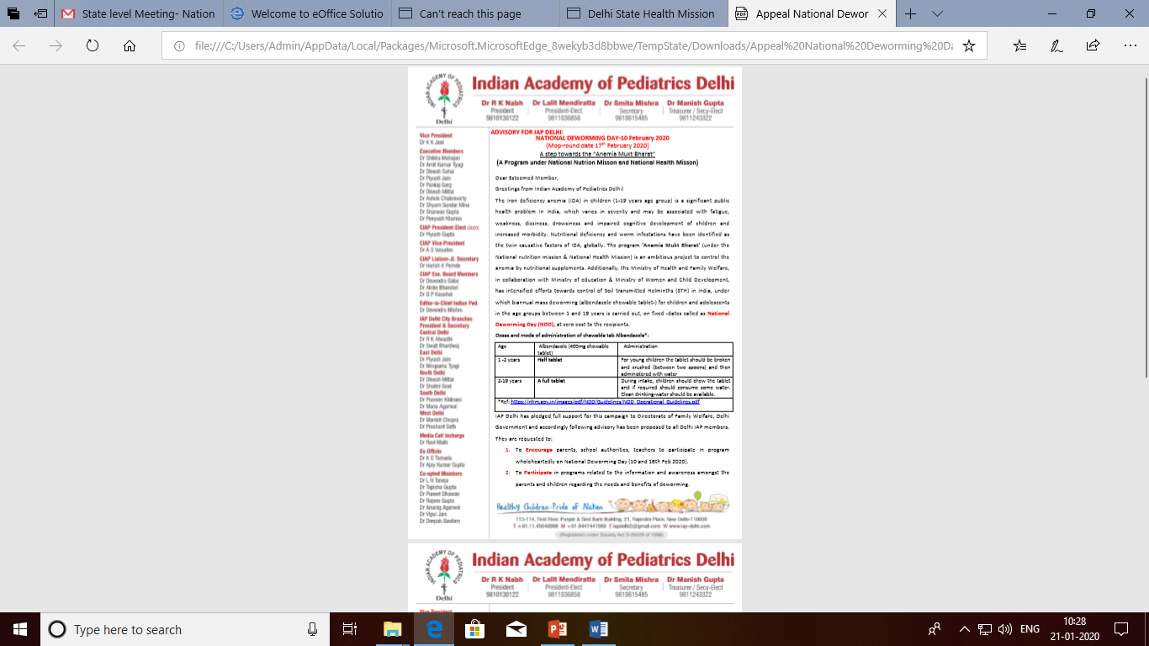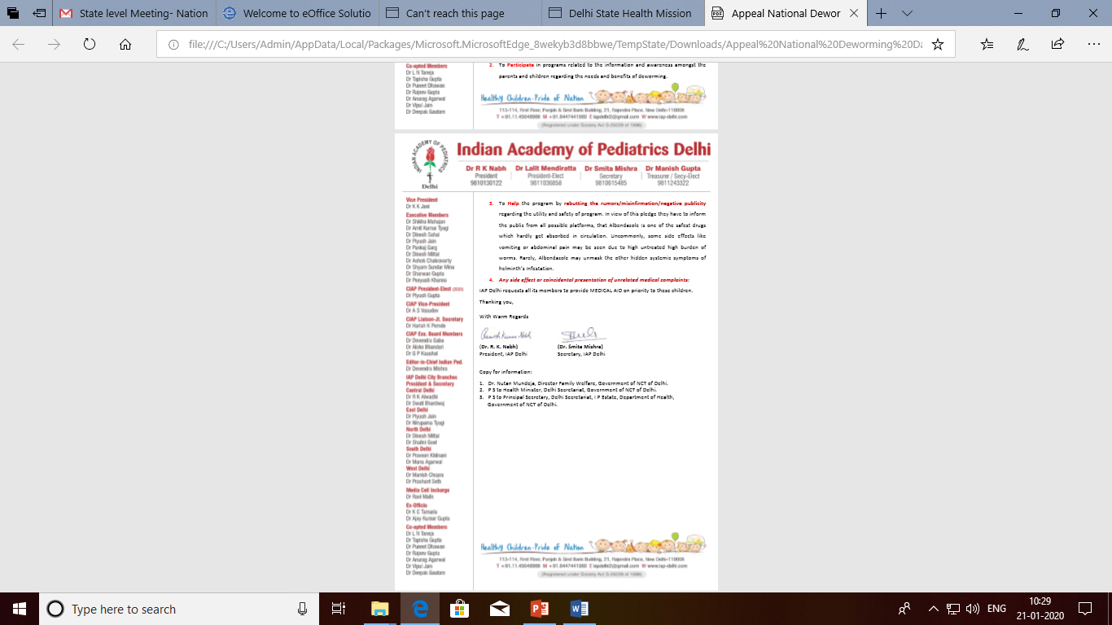

As a part of our commitment to a high quality NDD Program, Department of Health & Family Welfare ensures that the drugs being used are of standard quality.
A lthough Albendazole (the drug used for mass deworming) is considered safe, few adverse events such as nausea, vomiting, pain abdomen, fatigue, dizziness and in rare circumstances seizures may be reported. Most of these adverse events are mild and are transient in nature and are usually more pronounced in children harboring a higher worm load. Adverse events reported after administration of Albendazole may also be coincidental arising out of existing co-morbid condition/s in the child. Prompt and appropriate medical care needs to be ensured accordingly.
To tackle any exigencies on De-worming & Mop-up Day, Emergency Response System (ERS) is being put in place by the Department. As a part of ERS, in addition to the public hospitals that remain open for 24 hours on all seven days of the week, all Delhi Govt. dispensaries remain open and on High Alert for extended hours from 8: 00 AM to 6: 00 PM on both the days. Nodal Officers at public Hospitals are identified to ensure minimum response time in case of any emergency. Besides, CATS ambulance services remain on high alert on the program days.
Key Message to Parents/School Administration

- Administration of single, age appropriate dose of Tablet Albendazole to children is recommended by Govt. of India.
- Tablet Albendazole is safe and is used extensively across the globe for mass deworming.
- Tablet Albendazole used is of standard quality and is administered by trained teachers and anganwadi workers.
- Albendazole is not administered to acutely ill children/those on long term medications/ children with history of allergy associated with albendazole.
- Intestinal worms may cause malnutrition and Iron Deficiency Anemia. Albendazole helps children get rid of these parasitic intestinal worms.
- Parents and School administration are requested to come forward and ensure that all eligible children are administered Tablet Albendazole on National Deworming Day.

However, Administration of Albendazole during National Deworming Day is completely voluntary.

What if a Child could not be administered Albendazole on National Deworming Day (due to illness, absenteeism or any other reason)?

- Children who missed out on National Deworming Day (10th February, 2020) and are otherwise eligible for administration of Albendazole may be administered the drug on Mop Up Day -17th February, 2020

We appeal to all parents to make sure that their child is administered Albendazole on National Deworming Day and contribute in making Delhi a “Worm Free City”.

